**BUV SHUTTLE BUS OPERATION INSTRUCTION**

**Updated on July 23rd, 2024**

1. **GENERAL INFORMATION, RULES AND REGULATIONS:**

These regulations are created to ensure the safety and security of BUV students and staffs. Everyone should read the shuttle bus regulations. Failure to comply with the regulations may result in suspension or termination of bus service for individuals for a period of time.

1. BUV currently provides a transport service from Hanoi to BUV campus and vice versa which is operating from 6:45 AM to 7:30 PM.
2. BUV bus is a service between predetermined collection points and as such does require passengers to travel to a collection point. There is no private pick-up point applied. Any associated parking costs and arrangements are the users’ responsibility.
3. BUV buses only pick up and drop off passengers at the designated points.
4. BUV buses will depart at the scheduled times and do not wait for latecomers. Passengers are highly advised to arrive 5-10 minutes before departure time.
5. BUV students and staffs are required to wear BUV ID Cards when using the bus, other passengers who wish to use the bus should present an invitation email or document from BUV representatives.
6. Number of buses for every time slot is estimated and arranged based on the number of students attending classes at the nearest class time, in case there is a shortage of buses due to the inconsistent and unexpected bus usage routine of students, seats are allocated on a first come – first served basis and students will be prioritized over staff members.
7. Weekly bus schedule will be released on every Friday of the previous week. Students should keep an eye on their mailbox to get the most updated bus schedules. Should there be any changes, notice will be announced at least 1 day in advance.
8. BUV bus operates with 29-seater coaches, each of which should only transport a maximum of 29 passengers including the bus driver. Under no circumstances are more than 29 people allowed on a vehicle.
9. BUV reserves the right to cancel any bus route or bus slot if the number of users is constantly recorded as too low.
10. BUV students and staffs are strictly prohibited from carrying dangerous and flammable goods into the vehicle.
11. **BUS IMAGE**

The shuttle buses will have their appearance as below reference for your ease of recognition.

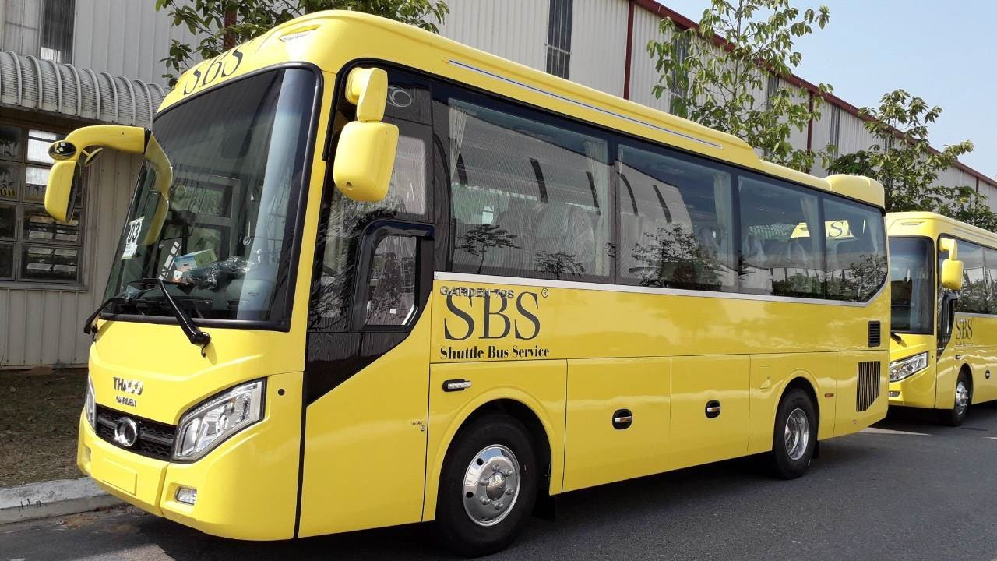

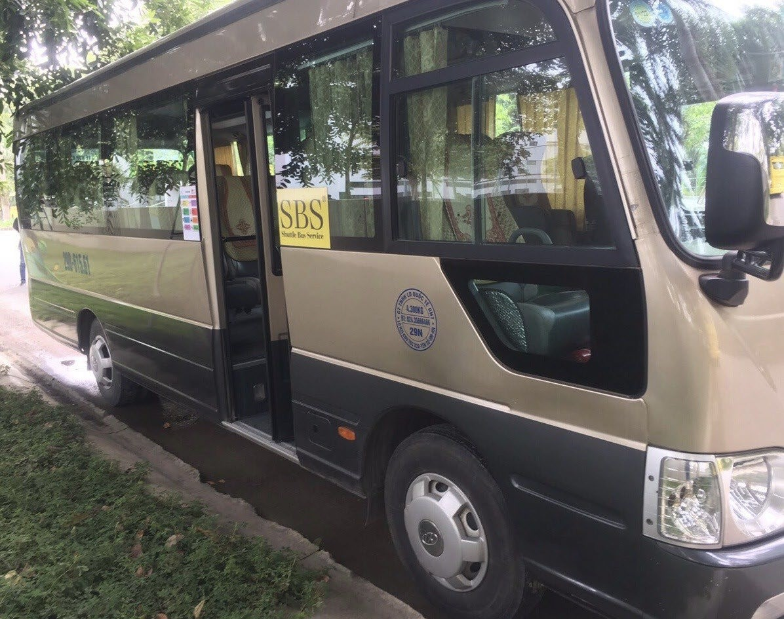

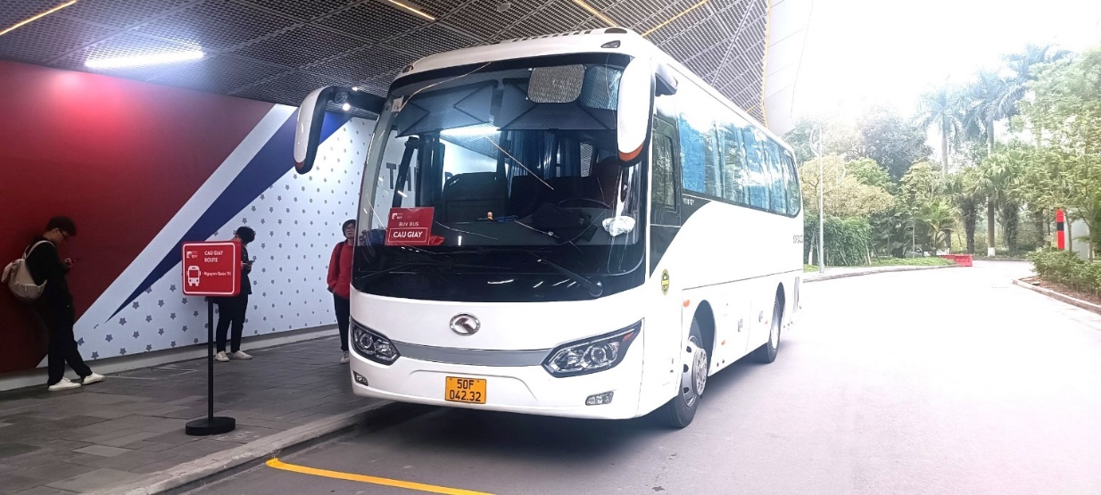

1. **ONLINE UPDATE FOR BUS SERVICE:**

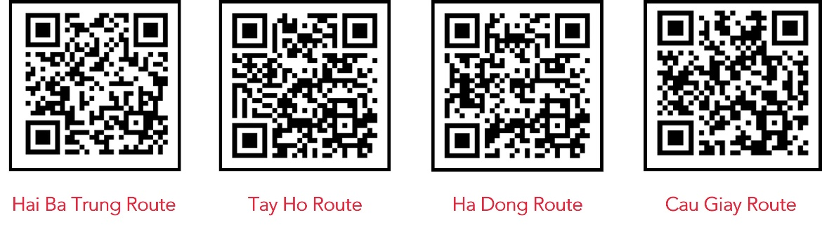You can immediately update the daily bus situation and weekly bus schedule by scanning QR code below or directly contact us at hotline 0704 068 386.

1. **BUS ROUTE**

Effective January 1st, 2023, BUV offered 4 bus routes from 4 main districts in Hanoi with several pick-up points in Hanoi and all designated pick-up points within Ecopark Township, please find the details of each route below.

**ROUTE 1 - HAI BA TRUNG**

**51 Le Dai Hanh→ Times City → AEON Mall Long Bien → Ecopark → BUV Campus**

**BUV Campus → Ecopark → AEON Mall Long Bien → Times City → 51 Le Dai Hanh**

* 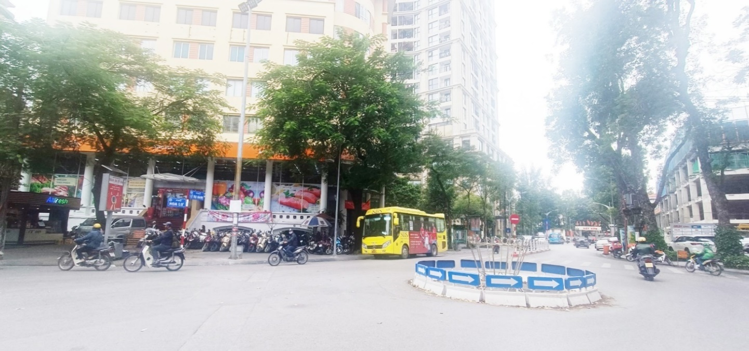 Pick-up/drop-off point: **51 Le Dai Hanh** **(BRG Mart), Le Dai Hanh, Hai Ba Trung, Ha Noi** - [GPS LINK](https://maps.app.goo.gl/5Z33GKjzCQ4HXm827)
* 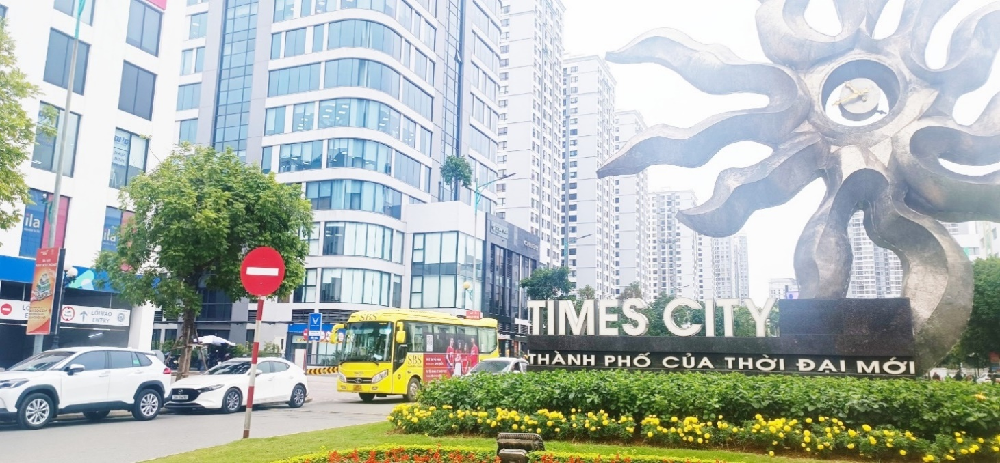Pick-up/drop-off point: **Tower 1 opposite the Sun symbol** **at** **458 Minh Khai**, **Times City, Hai Ba Trung, Ha Noi -** [GPS LINK](https://maps.app.goo.gl/TXhQPCe52VVa8Bn99)
* Pick-up point: **206 Co Linh, Long Bien, Ha Noi – opposite AEON Mall Long Bien (Under the overpass across the street from the mall) -** [GPS LINK](https://maps.app.goo.gl/1cHZ7NSBEd8G9q6v9)

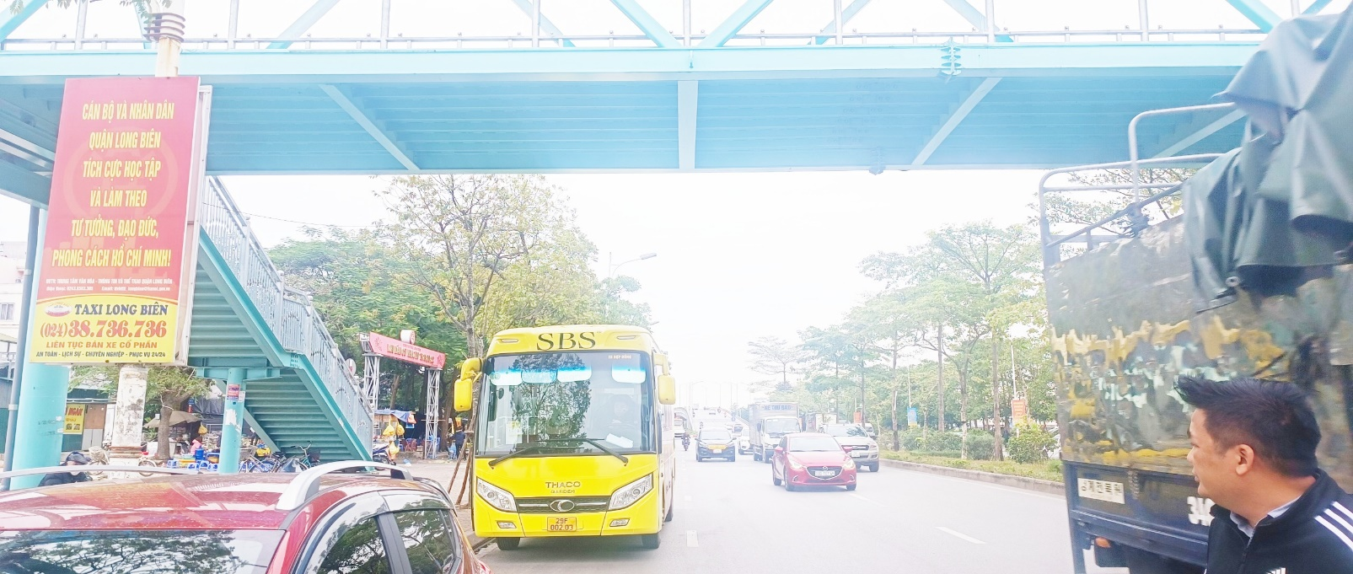Drop-off point: **27 Co Linh, Long Bien, Ha Noi - AEON Mall Long Bien (Under the overpass in front of the mall) -** [GPS LINK](https://maps.app.goo.gl/ZsKJAWvXWLYc7PFt5)

* Pick-up/drop-off point: **Rung Co E2, Ecopark, Van Giang, Hung Yen -** **bus stop** - [GPS LINK](https://maps.app.goo.gl/HogVQNkpkV3zpTmA8)

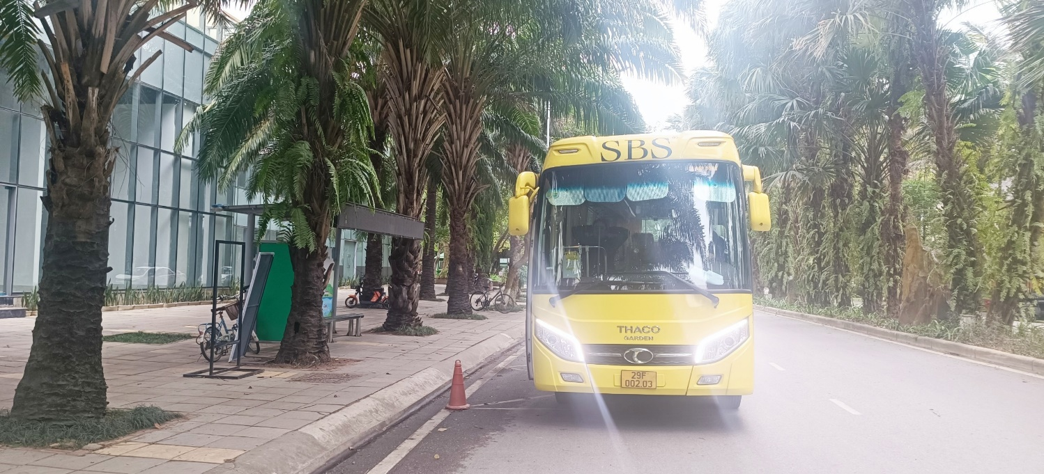

* Pick-up/drop-off point: **Sky Oasis - at the parking entrance between S2 & S3 Sky Oasis, Ecopark, Van Giang, Hung Yen -** [GPS LINK](https://maps.app.goo.gl/FRG5m5mVFYNXFWrL9)

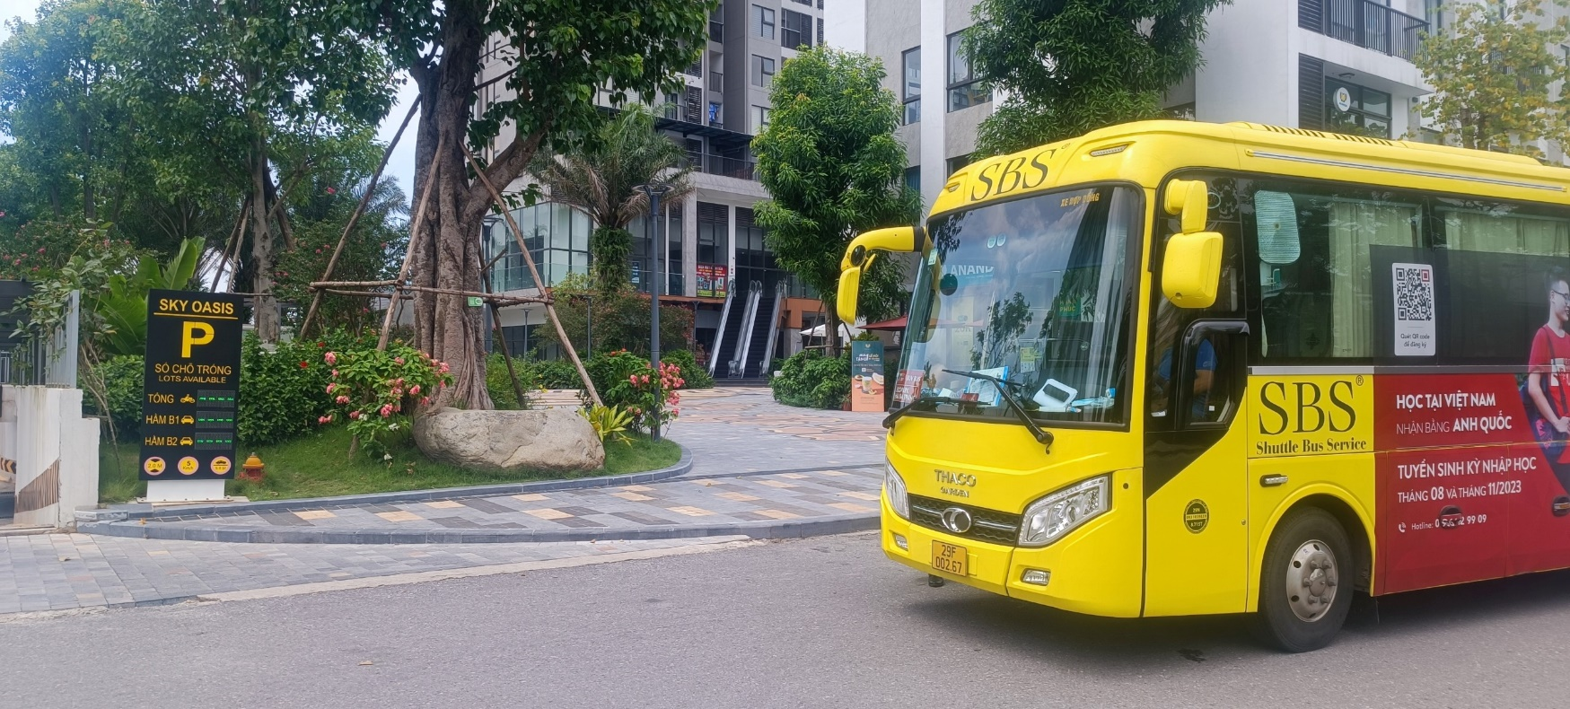

* Pick-up/drop-off point: Sol Forest & Haven Park, Ecopark, Van Giang, Hung Yen - bus **stop** - [GPS LINK](https://maps.app.goo.gl/aYqbSnEEjNNZNf8U7)

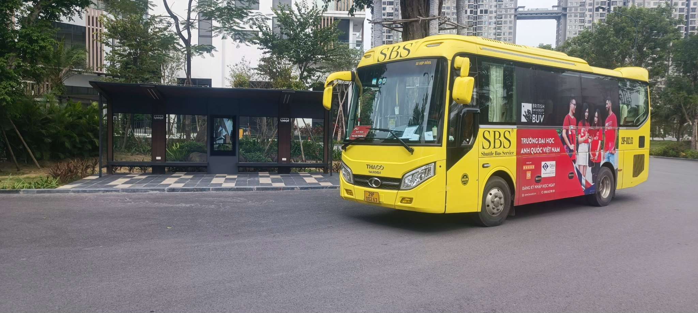

* Pick-up/drop-off point: **Landmark, Ecopark, Van Giang, Hung Yen** **- bus stop** - [GPS LINK](https://maps.app.goo.gl/fxBqBUoCJDyZ66689)

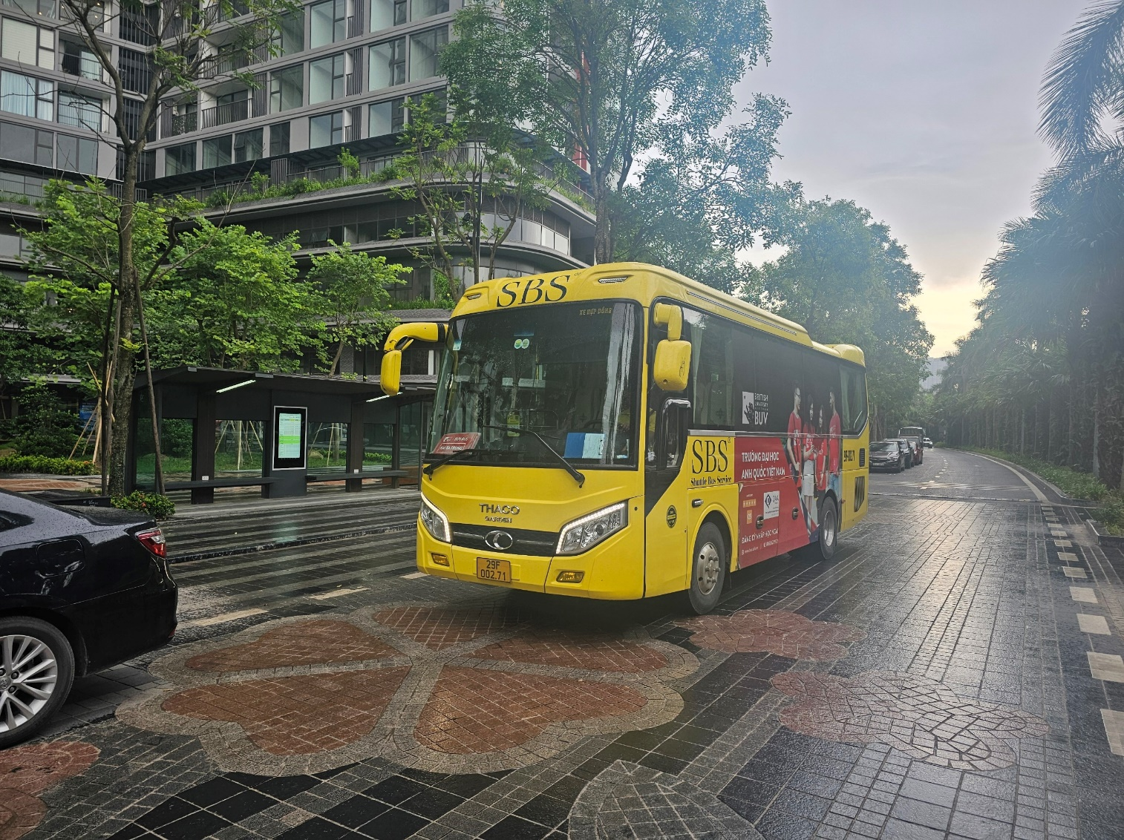

* Pick-up/drop-off point: **Swanlake, Ecopark, Van Giang, Hung Yen** **- bus stop** **–** [GPS LINK](https://maps.app.goo.gl/jPWL8FRrP2K7LcMt5)

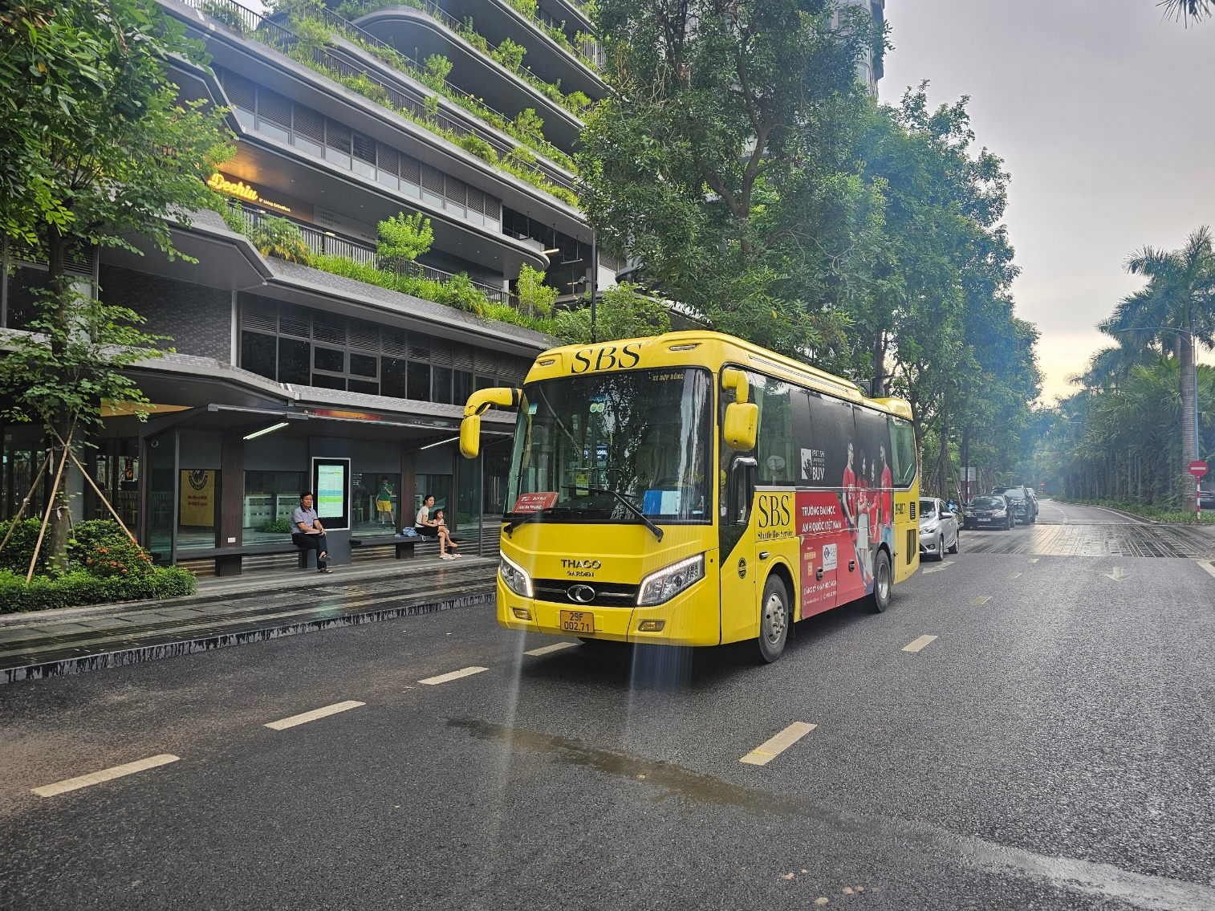

* Pick-up/drop-off point: **Westbay B**, **Ecopark, Van Giang, Hung Yen** - **bus stop** - [GPS LINK](https://maps.app.goo.gl/xKQ9D3Sdj7CbGMFa6)

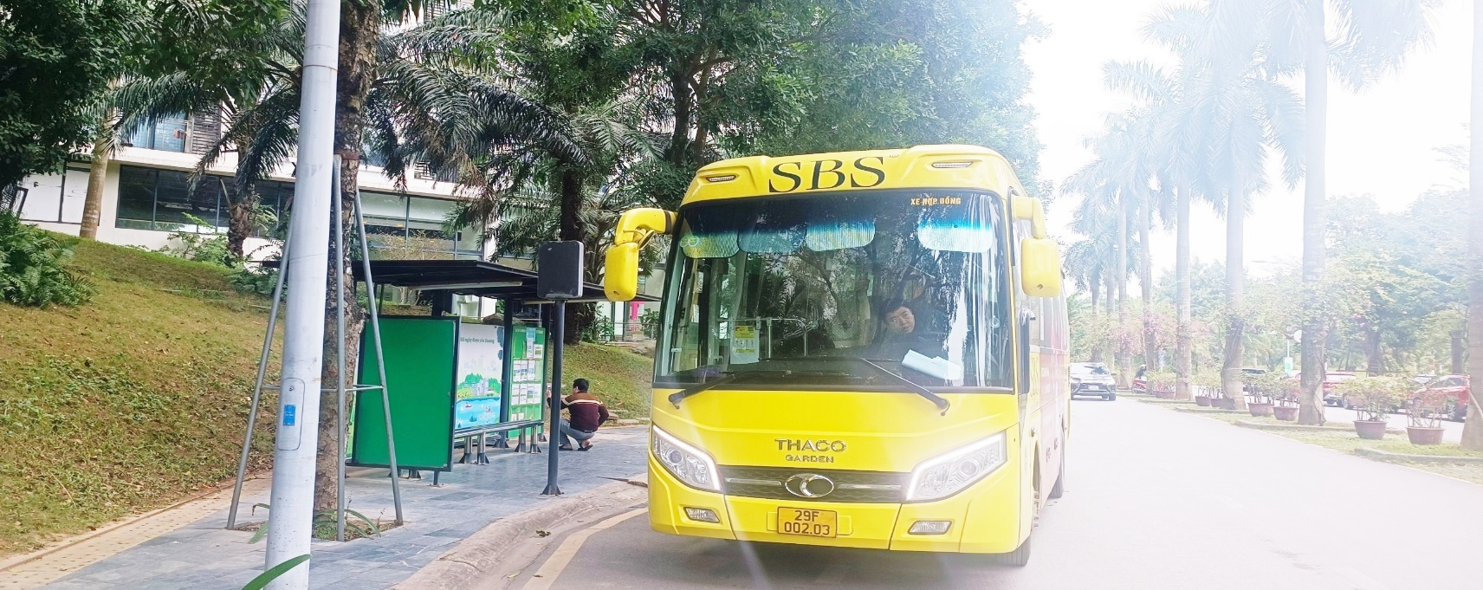

* Pick-up/drop-off point: **Westbay C, Ecopark, Van Giang, Hung Yen** - **bus stop** **-** [GPS LINK](https://maps.app.goo.gl/QTeop8dhy8sJkNDu5)

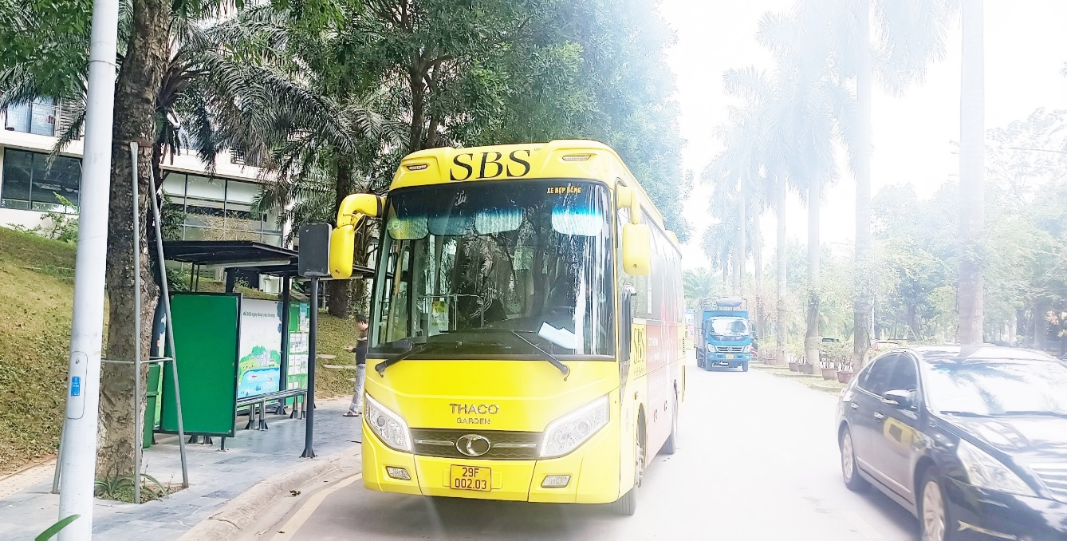

* Pick-up/drop-off point: **Aquabay Sky 2, Ecopark, Van Giang, Hung Yen** - **bus stop** - [GPS LINK](https://maps.app.goo.gl/bNHyGUa72MEGhg7e8)

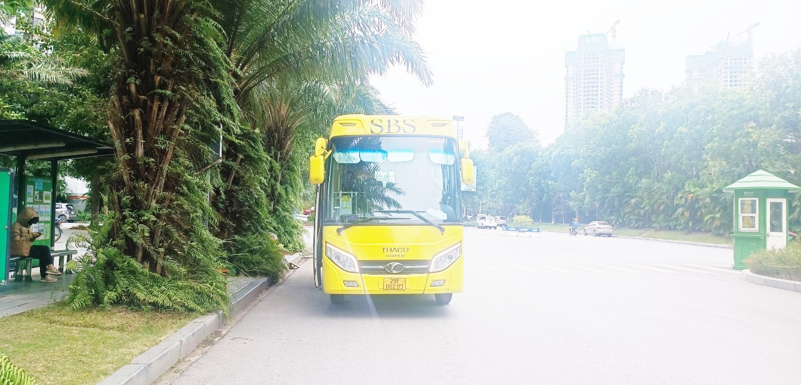

* 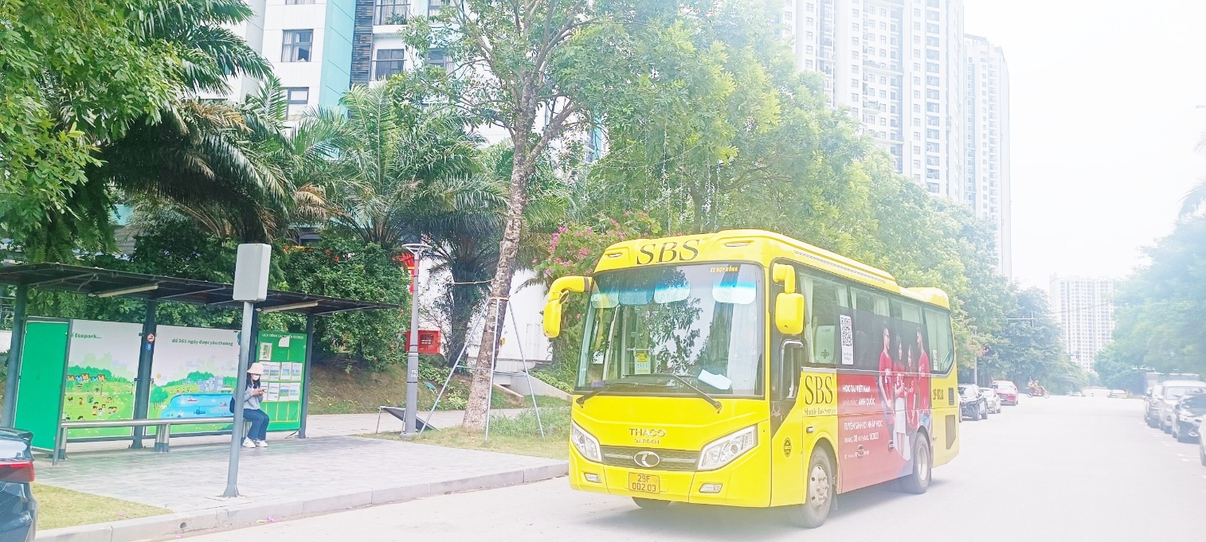Pick-up/drop-off point**: Aquabay Park 1, Ecopark, Van Giang, Hung Yen** - **bus stop** - [GPS LINK](https://maps.app.goo.gl/vxRZ7rZn31yb32mp9)

**ROUTE 2 – HA DONG**

**Ho Guom Plaza → 473 Nguyen Trai → Muong Thanh Grand Hotel → BUV Campus**

**BUV Campus → Opposite Muong Thanh Grand Hotel → Old Thanh Xuan Department Store → Ho Guom Plaza**

* Pick-up/drop-off point: **Ho Guom Plaza on the side at Vu Trong Khanh Street, Mo Lao, Ha Dong, Ha Noi** - [GPS LINK](https://maps.app.goo.gl/QShde2kSyFzbDhnb6)

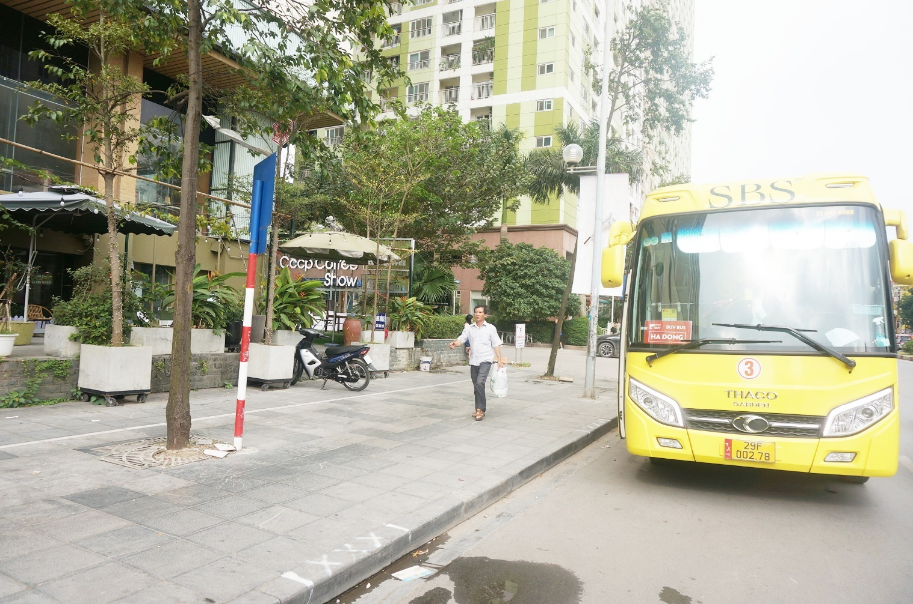

* Pick-up point: **473 Nguyen Trai, Thanh Xuan, Ha Noi -** [GPS LINK](https://maps.app.goo.gl/qQaUo6wmaLiBxrsT7)

Drop-off point: **Old Thanh Xuan Department Store, Thanh Xuan, Ha Noi –** [GPS LINK](https://maps.app.goo.gl/TgLSCHrMkpz1GSgMA)

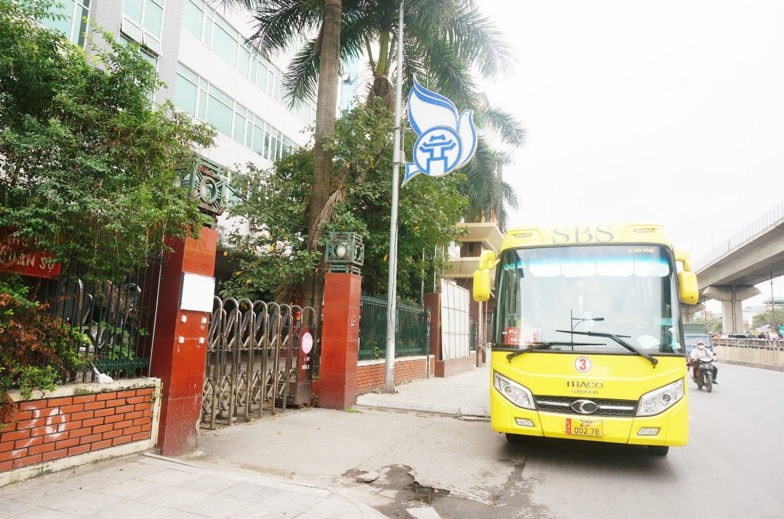

* Pick-up point**:** **Muong Thanh Grand Hotel, Nghiem Xuan Yem, Thanh Xuan, Ha Noi -** [GPS LINK](https://maps.app.goo.gl/XKUeywVLZ19RG7k38)

Drop-off point: **Opposite Muong Thanh Grand Hotel, Nghiem Xuan Yem, Thanh Xuan, Ha Noi –** [GPS LINK](https://maps.app.goo.gl/CoHEz7Q86gmSUeWdA)

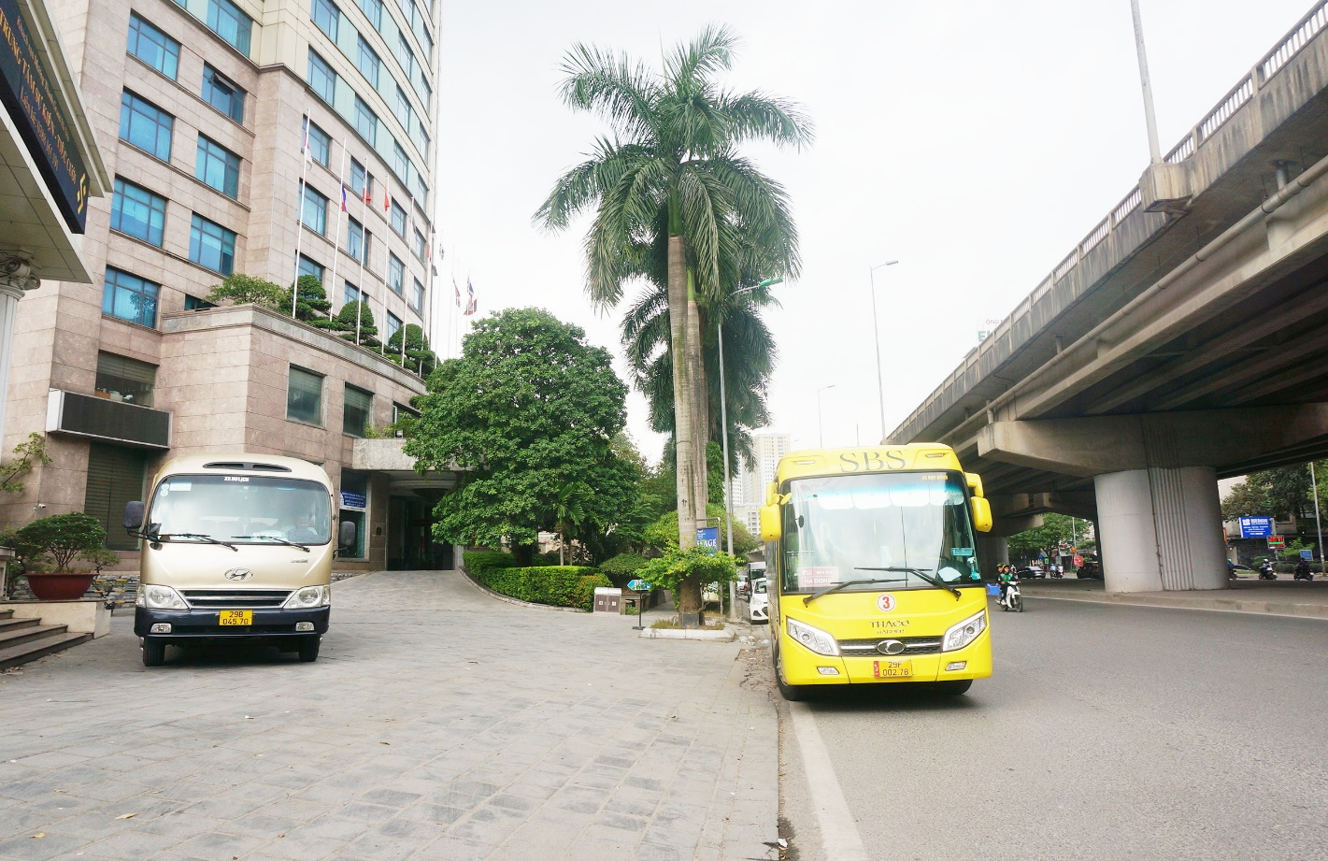

* Pick-up point: **No. 1, group 2, Linh Nam, Tran Phu, Hai Ba Trung, Ha Noi -** [GPS LINK](https://maps.app.goo.gl/gX5dE5SpGJHyySUCA)

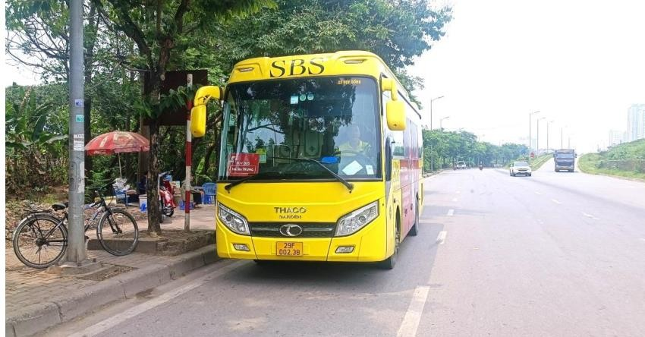Drop-off point: **634 Linh Nam, Tran Phu, Hai Ba Trung, Ha Noi** – [GPS LINK](https://maps.app.goo.gl/tXdoZQ4HNDLF5z3fA)

**ROUTE 3 – CAU GIAY**

**Nguyen Quoc Tri → Lang Ha → BUV Campus**

**BUV Campus → Lang Ha → Nguyen Quoc Tri**

* 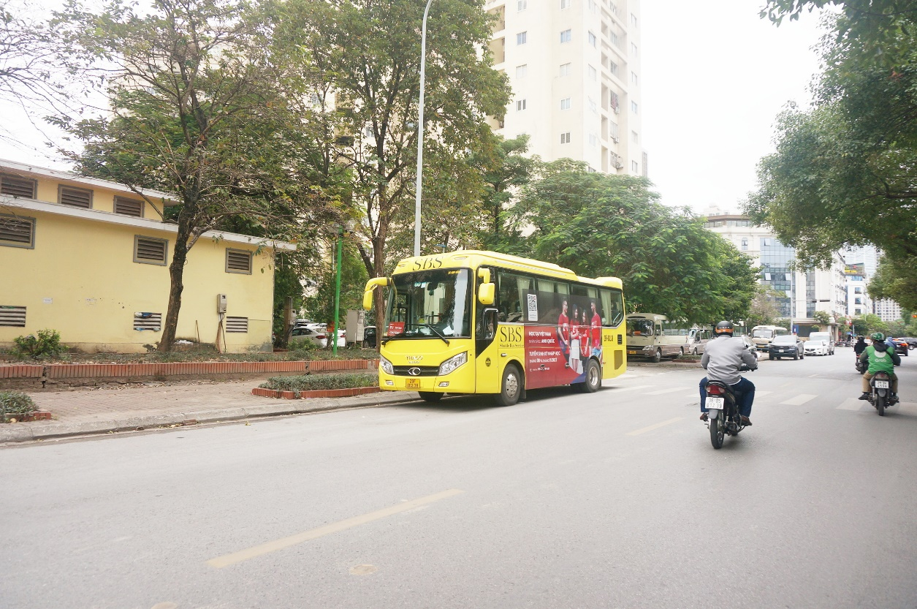Pick-up/ drop-off point: **B11 – D Nam Trung Yen building, Nguyen Quoc Tri Street, Trung Hoa, Cau Giay, Ha Noi -** [GPS LINK](https://maps.app.goo.gl/xsoTyrD46MiMMtDW8)
* 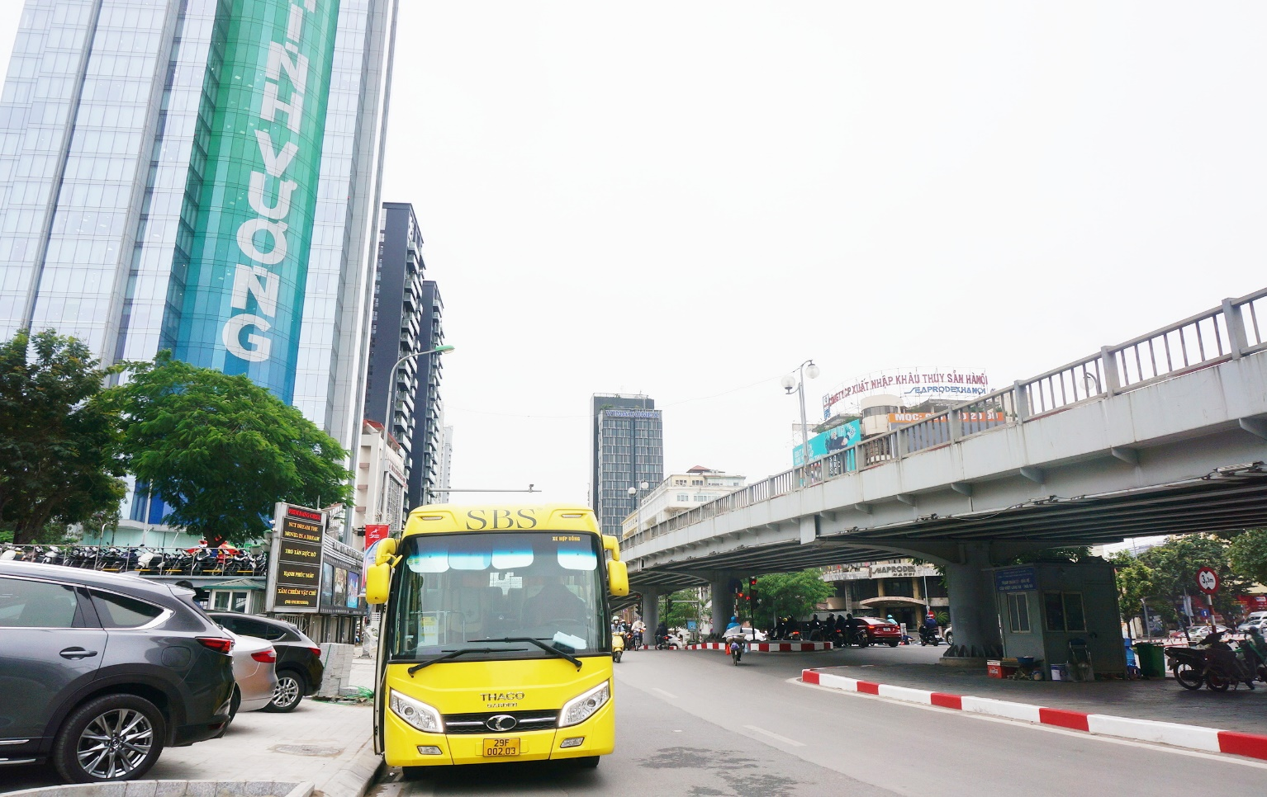Pick-up/ drop-off point: **National Cinema Centre 87 Lang Ha, Thanh Cong, Ba Dinh, Ha Noi -** [GPS LINK](https://maps.app.goo.gl/xd7R96WY3Aq9Poxk6)

**ROUTE 4 – TAY HO**

**Ho Tay Water Park → Nghi Tam → Tran Khanh Du → Vinhomes Ocean Park → BUV Campus**

**BUV Campus → Vinhomes Ocean Park → Hong Ha → Nghi Tam → Ho Tay Water Park**

* 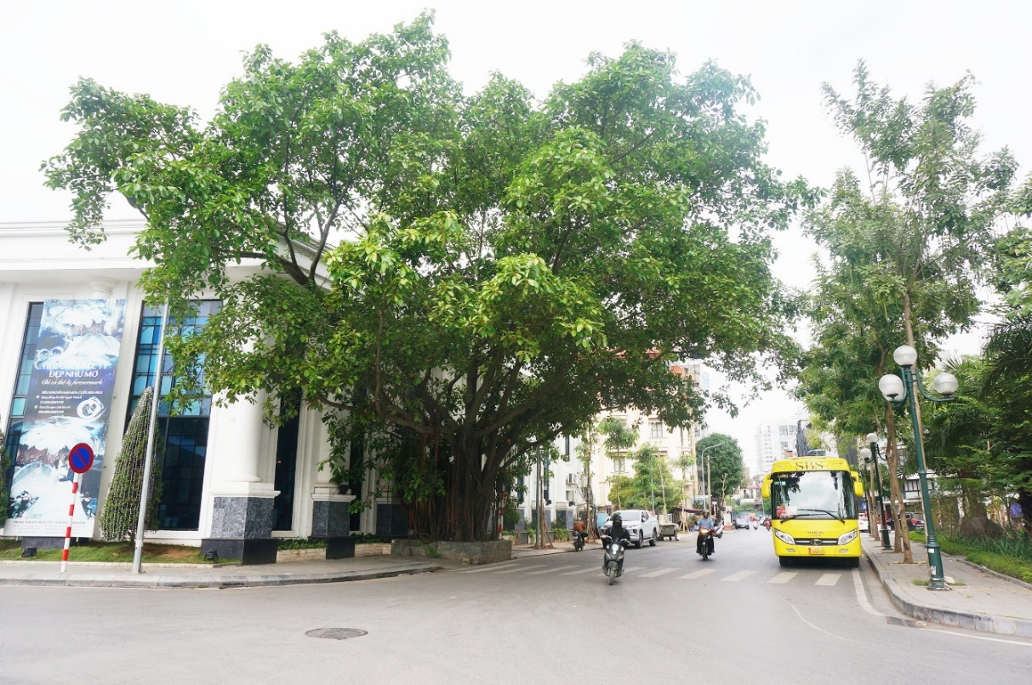Pick-up/ drop-off point: **Ho Tay Water Park at 614 Lac Long Quan (Near the gate of Ho Tay water park)** - [GPS LINK](https://maps.app.goo.gl/fsBji42rco4qtd9U8)
* Pick-up/ drop-off point: **197 Nghi Tam, Yen Phu, Tay Ho, Ha Noi –** [GPS LINK](https://maps.app.goo.gl/xR6cfBGVwRNwKqZh7)

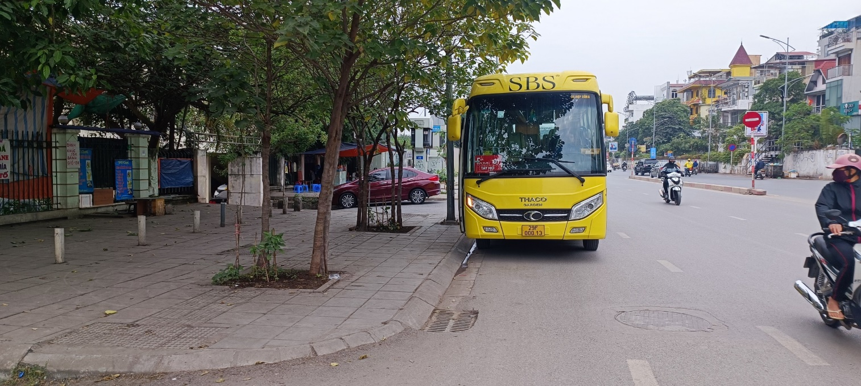

* Pick-up/ drop-off point: **Vietnam National History Museum at Tran Khanh Du street, Phan Chu Trinh, Hoan Kiem, Ha Noi** **–** [GPS LINK](https://maps.app.goo.gl/ZmNhZKhtXZUNBMbE6)

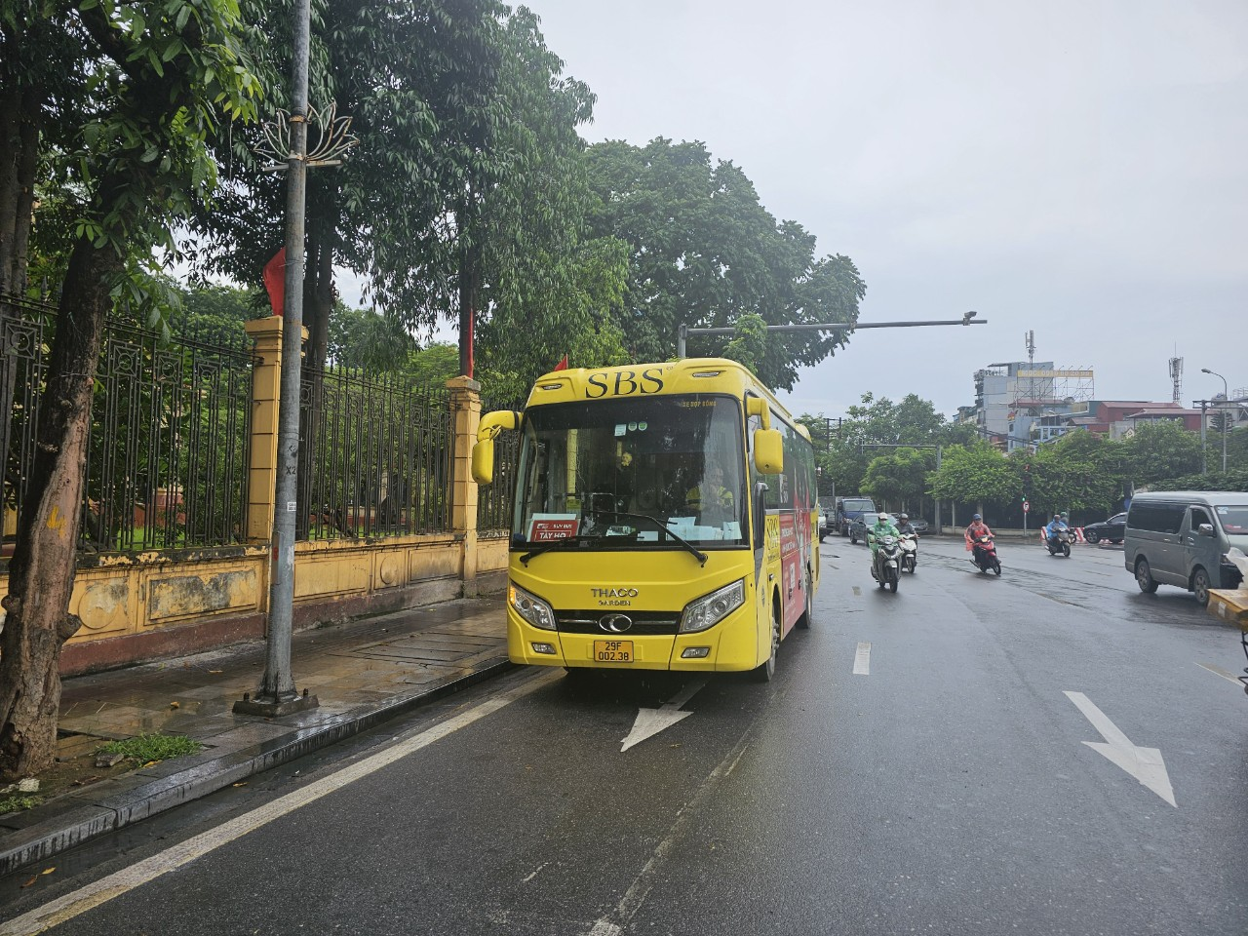

* 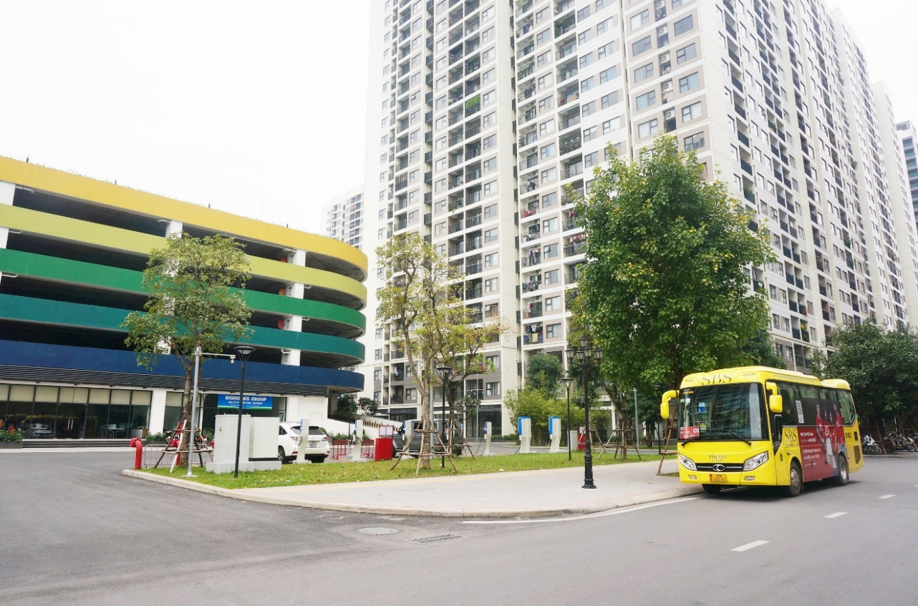Pick-up/ drop-off point: **Vinhomes Ocean Park (Parking area opposite building S208) -** [GPS LINK](https://maps.app.goo.gl/ZkmPSCg8qoUQWH4r6)

1. **PICK-UP & DROP-OFF POINTS AT BRITISH UNIVERSITY VIETNAM**

Pick-up & drop-off points at BUV for 04 routes will be demonstrated in the below image:

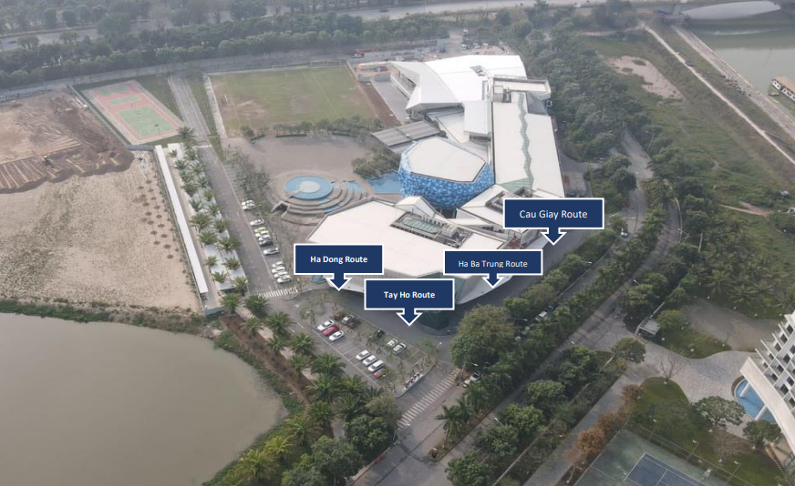

1. **HOW TO READ THE BUS SCHEDULE.**

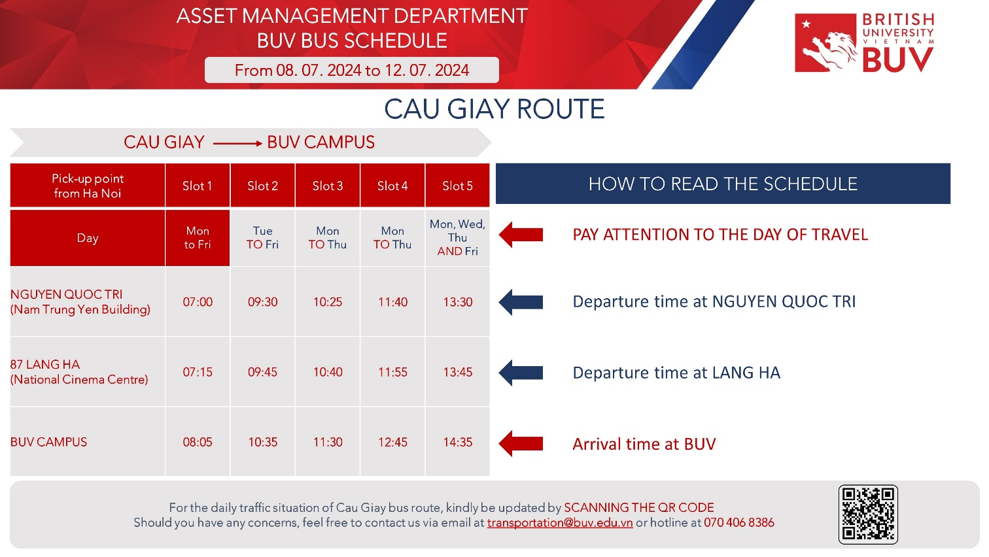

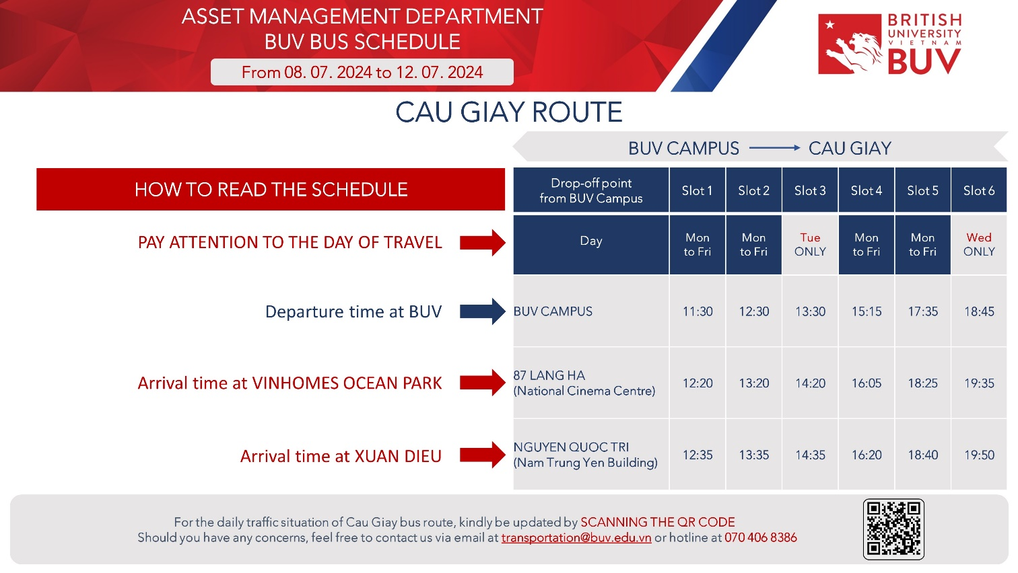

1. **CONTACT**

To be promptly assist or leave your feedback, please contact us at

* Hotline: (+84) 704 068 386
* Email: transportation@buv.edu.vn